APPENDIX B – Install guide

- At first, to run the software, you need to attach our database in database folder into your SQL Server application.
Right click on Database choose Restore Database …
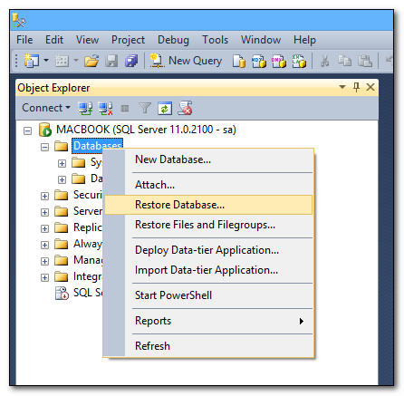
Choose file LMS.bak follow image: Choose Device > Click … button > Click Add > Choose LMS.bak in database folder.
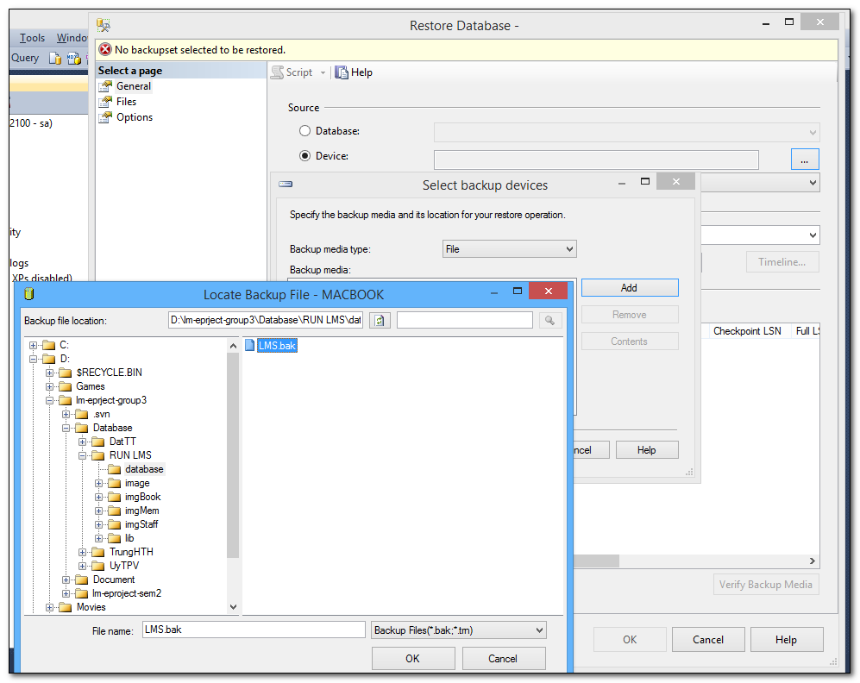

- Security→Logins→Right click username sa→Choice Properties.
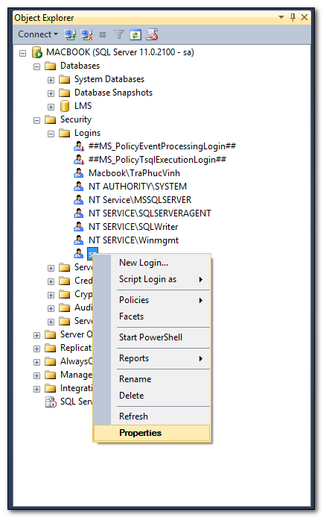
- Change two field Password and Confirm password with value “abc@123”. Unchecked Enforce password policy check box > Click OK to complete.
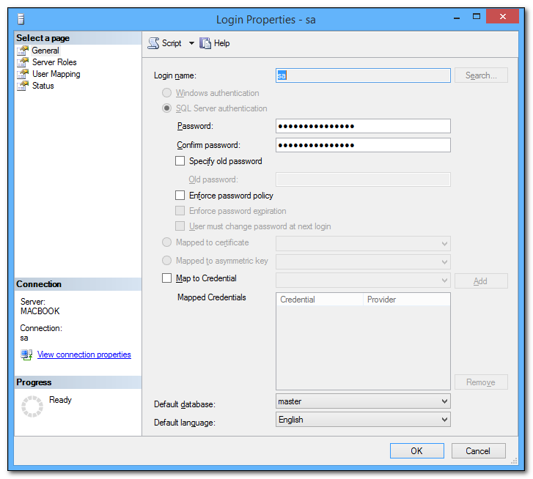
Setup Microsoft SQL Server TCP/IP connection and PORT
Application needs a connection to MS SQL database through TCP/IP, therefore if TCP/IP of MSSQLSERVER is disabled, data cannot be retrieved and in that case, application will be invalid.
Steps taken to enable TCP/IP of MSSQLSERVER:
- Run SQL Server Configuration Manager
- On SQL Server Configuration Manager window, click on SQL Server Configuration Manager (Local) → SQL Server Network Configuration → Protocols for MSSQLSERVER, check whether TCP/IP is disabled or enabled.
If enabled, assure that TCP/IP Port is set to 1433 and exit SQL Server Configuration Manager.
If disabled, go to next step.
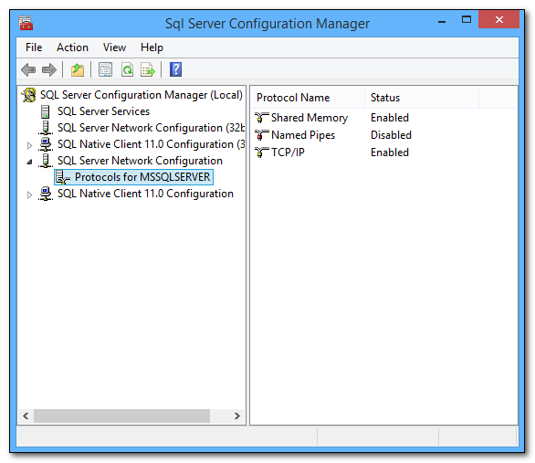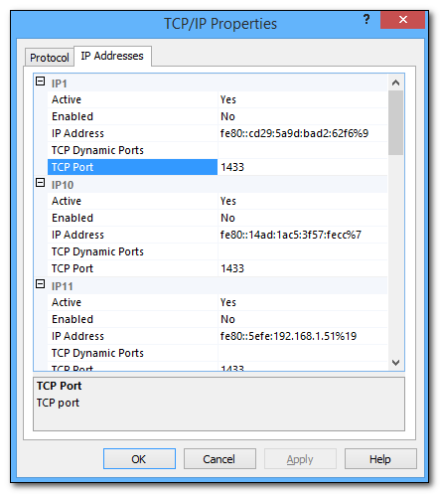
- Click on SQL Configuration Manager (Local) → SQL Server Services and stop. Restart MSSQLSERVER in SQL Server Services. And done.
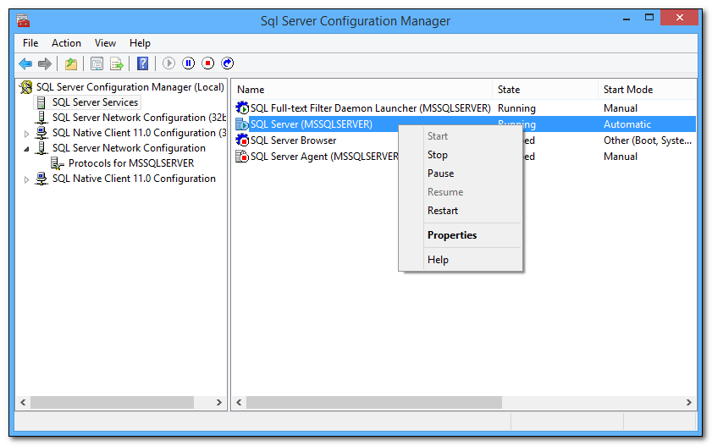
Run the application
Login to application: LIBRARY MANAGEMENT
Username Admin: TRUNGHTH | Password: ABC@123 | Role: Admin

